BRAKE TESTING

Static brake testing
Daily examination
Weekly examination
Monthly examination

Testing the protection

INTRODUCTION

When the wheel was invented it improved transportation and sped up activities with less labor and time. The brake, ironically, was invented to reduce speed and stop the wheel from turning. Many methods of braking systems have since been used on different types of machinery and transport, such as cars, trucks and mining equipment
No matter where brakes are used, it is very important that they function correctly. It is therefore necessary that all types of brakes on mine winders must be checked and adjusted in accordance with laid-down procedures and must comply with The Mines and Works Act and Regulations.
In this module we will discuss the testing and examining of mine winder brakes, in the following order :

Static brake testing

Daily examination
Weekly examination
Monthly examination

Testing the protection. (False bank test or Dynamic brake test).

STATIC BRAKE TESTING

DAILY EXAMINATION

The Mines and Works Act and Regulations No. 16.74 states:
“The person appointed in terms of regulation 2.13.1, 2.13.2 or 2.13.3 shall appoint in writing some competent scheduled person or persons whose duty it shall be to examine carefully – 16.74.1 at least once in each day the winding ropes, the balance ropes or tail ropes, the connection of the winding ropes to the drums, the connections referred to in regulation 16.18, the conveyances and the main members by which they are suspended and any safety catches attached thereto, the pulley wheels and sheaves, the brakes, the depth indicators, the safety devices and all external parts of the winding equipment upon the proper working of which the safety of persons depends : Provided that these examinations will not be necessary on any day mentioned in section 9(1) of the Act, if the winding plant makes less than 50 trips during any such day, and
16.74.2 at least once in each week the signaling arrangements and safety devices used in connection therewith”.

As can be seen from the previously stated regulation, the daily examination of the winder brakes is one of the most important duties of the responsible Fitter. Brakes could malfunction due to loose linkages, burst oil pipes or oil on the brake paths. The Fitter must therefore make a visual inspection of all the brake components to ensure that they function correctly before proceeding to carry out brake testing.

DAILY EXAMINATION

Before commencing any work or tests, check the Driver’s logbook for any reported faults that may have been entered by the Driver of the previous shift, and if there is a fault reported, rectify immediately.

When you are satisfied that all is in order, begin your tests by testing the brake holding power applied against the loaded conveyance at the bottom in favor of the loaded conveyance descending.
The brake holding power is to be greater than 125% of the full-load motor power or as laid down by the motor specification or you mine standards. A typical example of a Ward Leonard would be 5 250 amps without the brake slipping. Repeat the same procedure with the opposite conveyance and record the ammeter readings.
If slipping of the brake does occur, first notify the responsible Engineer and he will decide what corrective action must be taken. Another possible cause could be oil on the brake path, in which case immediate action to clean the brake path must be taken, using an approved cleaning solvent. Test the brakes again after the cleaning process.
You can now check the brake stroke of the brake engine for the conveyance, which is at the bank or top of the wind. An indicator is mounted on the brake engine and a pointer indicates the length of the brake stroke on a marked face plate. This is illustrated in Fig. 1 for this type of brake engine.

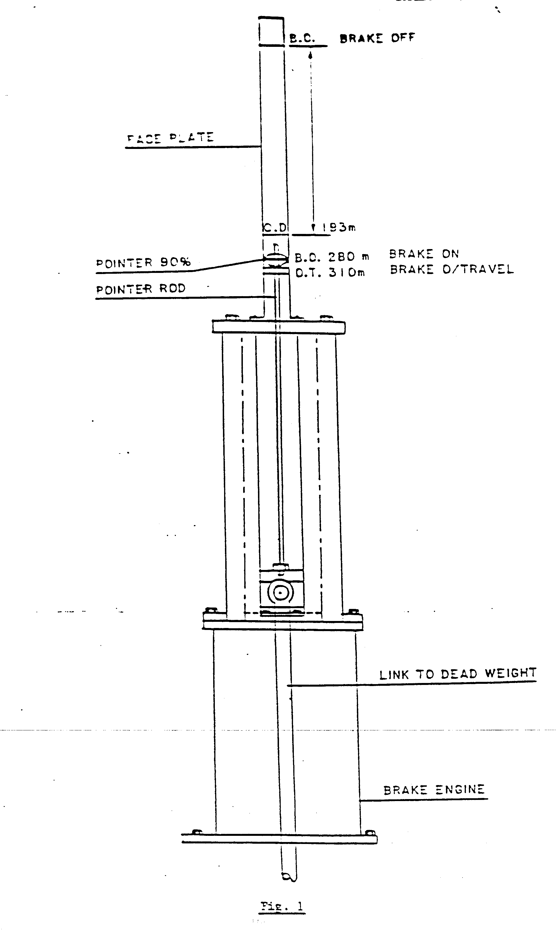
By interlocking the clutch, the Driver releases only the brake that has to be tested. The pointer will move up to the brake-off mark. The 90% and full stroke of the brake must be 260 and 280 mm respectively. To ensure the times are correct, a stop watch must be used. This applies only to winders with dead-weight type brake system s brake strokes and times vary on different winders.
Proceed as follows :

The brake must be fully off.

Position yourself, so that the brake engine indicator can be observed and the overwind trip switch on the speed and distance controller can be easily reached.

Trip the switch and start the stop watch simultaneously.

When the pointer reached the “90% on” mark, stop the watch and record the time, which must be + 1,5 seconds. Repeat the test on the opposite brake.

On the brake engine indicator there is another mark at 310 mm. This indicates the wear allowed before the brake-over travel alarm will sound. This could be due to wear on the brake or loose linkages, which must never be allowed to occur.
Testing the slow braking times is normally done in the following manner. All the tests are done at the “90% on” mark on the indicator. Although the winder is on full slow braking four turns out of the bank area, it is advisable to move both conveyances to mid-shaft. The conveyances will then be at a point of balance and both brakes can be tested without moving the winder again.
Follow the same procedure as described previously, excepting that the brake will have a quick drop and the indicator will move onto the 90% mark much slower.

This time will be in the region of + 7 – 7,5 seconds. If you find the time slower or faster than that stated, it must be rectified immediately by adjusting the fast/slow braking control valve which is dealt with in Module F.C.9 – 8(3). These times must be recorded in the book kept by the Fitter for his own reference and the Driver’s Logbook and the Machinery Record Book must be signed daily accordingly.

WEEKLY EXAMINATION

Brake testing on the weekly examinations is done on the same principle and the procedure remains the same, except that on the weekly examination the test times and the brake lining thickness must be measured and recorded in the Machinery Record Book.
The minimum thickness of the Ferodo must not be less than 8 mm. The brakes, pins, links and locking devices must be examined and lubricated. Clearance on the brake paths in the “brake full off” position must be 2 mm with a maximum tolerance 0,25 both top and bottom, or according to your mine standard.
All work done on the winder and any adjustments on the brakes or brake times must be recorded in the Machinery Record Book and also entered in the Driver’s Logbook. An example to these specifications is given in Fig. 2.
MONTHLY EXAMINATION

The monthly examination of the brake testing on the winder is done in the same manner as daily and weekly brake testing. A Technician from the manufacturers or one of your mine’s inspection team does an inspection monthly on each winder. These examinations vary from month to month, for instance one month a full examination on brakes, then safety circuits and then the remainder of the winder equipment. These examination reports are then sent to the mine according to your mine’s procedure.
From these reports the Engineer is able to follow up if defects which were reported the previous month, such as defective brakes or oil leaks, have been repaired.

TESTING THE PROTECTION (FALSE BANK TEST OR DYNAMIC BRAKE TEST)

It is important that, at the end of the wind, the winder cannot be driven at a speed greater than that from which the brakes can retard the conveyance safely and although not included in the regulations, it has become practice that the “landing speed” of conveyances at their end-of-wind destination should not be allowed to exceed 1,5 m/sec. The reason for doing the following test is to determine the maximum speed the winder will trip at, when it reaches the bank. It is also to determine the rates of retardation in the bank area and to determine whether the conveyance will pass the bank at full speed should the winder not be retarded in the normal manner, i.e. the Driver fails to physically stop the winder.
Before dynamically testing the winder brake system, we must be sure that the protection system is operating correctly. The recently amended regulations call for “dynamic testing of the automatic overwind and overspeed prevention devices at least once in every 6 months or at intervals not exceeding 200 days”. This is taken to infer the running-in tests to a false landing should be carried out. The following is the recommended procedure to be followed on winders fitted with speed and distance controllers having governors:

Clutch and position both conveyances at the extremities of the wind.
Load the lower conveyance with a full load equivalent to a full men load.
Clearly mark the position of both vernier half couplings relative to each other on the drive to the speed and distance controller and cam gear of the upper conveyance only.
Remove the bolts from these Vernier couplings and separate coupling halves.
Lower the upper conveyance 5 turns into the shaft, at the same time raising the lower
conveyance 5 turns up the shaft. Ensure that the uncoupled speed and distance controller and cam gear does not move.
Now, without moving the uncoupled coupling halves, insert the coupling bolts in corresponding holes and tighten. The upper conveyance will now have an artificial landing 5 turns down the shaft. On DC winders the automatic slow-down apparatus must be rendered inoperative for these tests.
Creep the upper conveyance past the artificial landing point and allow it to trip on over-wind. Record the distance relative to the landing.
Establish the minimum trip speed setting of the controller by stopping the conveyance 2 turns from the artificial landing, holding the cam dial of the speed and distance controller so that the roller is on the same point of the deceleration cam as it would be if the conveyance were at the bank or tip, and accelerating the conveyance gently towards the bank until an overspeed trip occurs. This speed must not exceed 1,5 m/sec.

Then allow the conveyance to pass the artificial landing at just under this minimum trip speed 1,0 m/sec. The winder will trip on overwind. Record the position of the conveyance relative to the artificial landing
With the upper conveyance to pass the artificial landing apply full power with the control lever to raise this conveyance (driving the load down) and rapidly release the brakes.
Record the stopping position of the conveyance relative to the artificial landing, after tripping and the conveyance has come to rest.
Wind the upper conveyance a few turns down the shaft and then run it towards the artificial landing at a steady 2,5 m/sec, and allow the winder to trip on overspeed. Record the position of the conveyance relative to the artificial landing.
Repeat these tests at increments of 2,5 m/sec, until the final test is conducted, with the conveyance approaching the artificial is landing at full speed.
Tabulate the results of tripping speed and distance between the point at which the conveyance came to rest in each case and the artificial landing. When these tests are carried out on AC winders, dynamic braking must not be used to maintain a constant speed.
After completion of the full speed trip test, at the artificial landing, disconnect the Vernier couplings. Raise the upper conveyance 5 turns back to the actual mark, recouple the couplings, making sure the marks correspond, and tighten. Test over- and under-wind trips.
Repeat these tests for the opposite lower limits, starting at point 1 again and follow the same procedure. Record all the relevant facts on the form supplied as shown in Fig. 3, which must be submitted to the responsible Engineer, and also recorded in the Machinery Record Book.
This is purely an example, and tests must be carried out according to your mine’s procedure.

